

**Training & Supervision Agreement**

**(TSA)**

for PhD candidates of the PhD programme Medical Imaging (ImagO)

Version May 2019

**Preface**

Dear PhD candidate,

Welcome to the PhD programme Medical Imaging (ImagO). This programme is part of Utrecht University’s Graduate School of Life Sciences (GS-LS). The GS-LS unites 14 thematic PhD programmes that offer training in specific areas of Life Sciences research. As specified in the *Quality Assurance Plan of training and supervision of PhD candidates of the Utrecht University Graduate School of Life Sciences* you are required to fill in this Training Agreement. The agreement specifies the rights and duties of you and your supervisor(s) with respect to training during the PhD track.

**Supervision**

During your PhD track, you will be supervised by one or more **supervisors** (*promotores*: full professors, the primary supervisor being affiliated with Utrecht University or UMC Utrecht) and one or more **daily supervisors** (*copromotores*: associate or assistant full professors of Utrecht University, UMC Utrecht or other knowledge institutions). In addition, a **Supervisory Committee** (*aio-begeleidingscommissie*) must be appointed, consisting of 1 scientist who is not involved in your project.

**Training & Skills**

At the start of your PhD track, it may not be entirely clear yet which training, workshops, courses, seminars, symposia etc. you will attend during your PhD track. Still, it is important for you that you discuss the knowledge and skills you will need to acquire in the course of your PhD track with your supervisor(s) right from the beginning. You will discuss this TSA and your progress on the development of different competences during the annual meetings with your supervisor and with your Supervisory Committee.

**You need to submit the agreement within three months after the start of your PhD track** **by e-mailing it to R.Allebrandi@umcutrecht.nl.**

**1. The PhD candidate**

|  |  |  |  |  |
| --- | --- | --- | --- | --- |
| **Name** |  | | | |
| **Academic education** |  | | | |
| **Date of birth** (dd/mm/yyyy) |  | | | |
| **Work e-mail address** |  | | | |
| **Type of appointment (select one)** | AIO (PhD candidate) | AGIKO/ AIOS/ ADIKO/ ZAPIKO | (Medical) specialist | External candidate* |
| **Appointment** (dd/mm/yyyy) | **Start date:** |  | **End date:** |  |
| **Faculty of appointment** |  | | | |
| **Department / Division** |  | | | |
| **\* Institute of appointment (for external candidates)** |  | | | |
| **Supervisor(s)** |  | | | |
| **Project title** |  | | | |

**2. Supervision**

**In case of long-term absence of the daily supervisor his/her obligation to fulfil this agreement will be taken over by:**

Title and name :

Position :

Affiliation :

**Name of the member of the mandatory Supervisory Committee (*aio-begeleidingscommissie*)**

The role of the Supervisory Committee is to provide independent advice to both (daily) supervisor(s) and you with respect to the progress (rate, direction) of the PhD track. The Supervisory Committee consists of 1 member. This is preferably a full professor or at least an assistant professor who is not directly involved with your research. The preferred candidate should not be employed in the same department as your supervisor or daily-supervisor. Your supervisor is responsible for appointment of the Supervisory Committee.

The minimum contribution of the Supervisory Committee is to discuss your annual progress report with you and your supervisor(s). Especially before one year after start of the PhD track, before the go/no-go decision, the contribution of the Supervisory Committee is very important. In general, the discussion must focus on achievements, progress and planning of research and training, feasibility of the project, quality of meetings between you and your supervisor(s), and quality of the infrastructure.

Questions that may be addressed by the Supervisory Committee include:

* Which are the results of the previous year?
* Is the project, and subprojects, realistic and feasible within the timeframe planned?
* Has a clear planning with regard to research and training been agreed between PhD candidate and (daily) supervisor(s) for the following year?
* Which are the expected bottlenecks? How will they be managed?
* Which results need to be obtained for future publications?
* Are the research facilities adequate?
* Is the quality (length, frequency) of meetings between PhD candidate and (daily) supervisor adequate?
* Are you apt to continue the project?
* Which of your skills and knowledge require improvement?
* How will this be achieved?

Name :

Affiliation :

**Min. contribution : 1 hr/year**

**3. Proposed training programme**

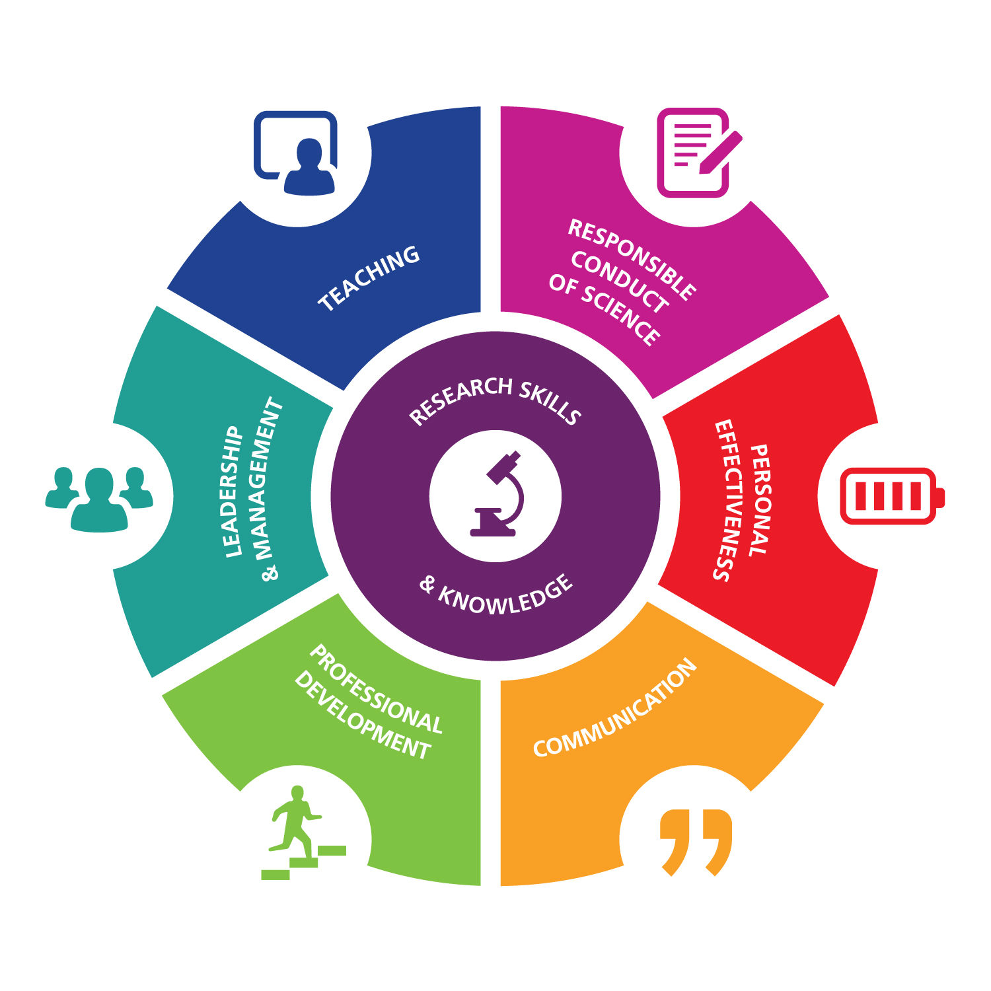

It is important to develop your competences as a researcher and as an individual. Meaningful competences to develop are; *Research Skills & Knowledge*, *Responsible Conduct of Science*, *Personal Effectiveness*, *Professional Development*, *Leadership & Management*, *Communication* and *Teaching*. These competences lead to further development for an academic future as well as for a future outside academia. The total training programme may constitute of a mixture of courses, seminars, journal clubs, PhD retreats, symposia, etc.

Disciplinary or thematic courses will be offered by the PhD programmes. Other courses and workshops (e.g. general courses) may be followed within the [PhD Course Centre](http://www.bit.ly/PhDCourseCentre). Of course, you may also attend other courses that are useful to you.

**Content of the programme**

The proposed programme should be constituted as follows:

* Training and education should comprise a minimum of 5 credits**[1]** for each year of research appointment, which will be at least 2 years and no more than 4 years (10-20 credits in total).
* A **minimum of 40%** of the total credits should be spent on **disciplinary or thematic courses of the PhD programme** **Medical Imaging (ImagO)**
* Courses offered by other PhD programmes of the GS-LS may be attended free of charge, if space permits (contact the programme coordinator in advance).
* A **minimum of 20%** of the total credits should be spent on **general courses**.
* A **maximum of 20%** of the total credits may be spent on symposia/conferences.

**Important**

The TSA must be filled in to the best of your efforts **within the first three months of appointment**.

You should keep track of the progression and adjustment of your training programme by collecting and saving the certificates of attendance that are provided by each course in a PhD Training Portfolio. You will need this information for the annual progress reports. Moreover, at the end of the PhD track, your programme coordinator will need them to be able to assess whether you qualify for the PhD Training Certificate of the GS-LS.

|  |  |  |
| --- | --- | --- |
| **Training programme (rows may be added if necessary)** |  |  |
| **Courses and training offered by the PhD-programme**  **(min. 40% of total)** | **Organising Institute** | **European**  **Credits[2]** |
|  |  |  |
|  |  |  |
|  |  |  |
|  |  |  |
|  |  |  |
|  |  |  |
|  |  |  |
|  |  |  |
|  |  |  |
|  |  |  |
|  |  |  |
|  |  |  |
| **General courses and training (min. 20% of total)  (e.g. from the PhD Course Centre)** |  |  |
|  |  |  |
|  |  |  |
|  |  |  |
|  |  |  |
|  |  |  |
|  |  |  |
|  |  |  |
|  |  |  |
|  |  |  |
|  |  |  |
|  |  |  |
|  |  |  |
|  |  |  |
| **Other disciplinary/thematic or general training** |  |  |
|  |  |  |
|  |  |  |
|  |  |  |
|  |  |  |
| **TOTAL** |  |  |

**4. Monitoring and reporting**

4.1 You must prepare **annual progress reports** according to the guidelines provided by the GS-LS (see end of this document). No later than 1 month before the end of each consecutive year of research[3], and two weeks prior to the regular annual interview with the Supervisory Committee, you provide the Supervisory Committee, (supervisor(s), and daily supervisor(s) with a progress report.

4.2 Besides these annual meetings with the Supervisory Committee your supervisor is responsible for the timely planning and conducting of regular **assessment interviews**.These interviews are held according to the guidelines of the faculty of employment.This includes the authorization of the continuation of your candidacy before the end of the first year (go/no-go decision).

4.3 You keep a personal **PhD Training Portfolio**. This portfolio contains all documents (e.g. certificates of attendance/participation) pertaining to your progress in your personal training programme and in the overall PhD programme, as indicated by GS-LS guidelines (see the end of this document).

**5. The Training Certificate of the GS-LS**

You will be able to receive a Training Certificate of the GS-LS, if the Training & Supervision Agreement is formally approved and when the requirements of the GS-LS with respect to training of PhD candidates are fulfilled (paragraph 3), as evidenced by the PhD Training Portfolio.

At the end of the PhD track the director/coordinator of the PhD programme evaluates your qualification for the Training Certificate on behalf of the Board of Studies of the GS-LS. The procedure for application of the Training Certificate and the application form can be found on the website of [Medical Imaging](http://www.imago.uu.nl/info-for-phd-candidates/) (ImagO). At least **four weeks** before the thesis defence the digital copy of the application form is sent via email to Ms. Renée Allebrandi**.**

**6. Compliance with general rules and regulations**

This agreement will comply with Dutch law, the doctoral degree regulations of Utrecht University, and the collective labour agreement of the Dutch universities (CAO NU).

**7. Guidelines for the PhD Training Portfolio**

The PhD Training Portfolio provides a cumulative record of written evidence pertaining to your training. You are responsible for the accuracy and completeness of the contents of the PhD Training Portfolio.

In order for you to qualify for the Training Certificate, the PhD Training Portfolio should contain at least the following:

1. Written evidence (certificates of attendance) of successful completion of all elements of the education and training programme;
2. Signed copies of all annual progress reports;
3. Lists of publications (printed or in press), manuscripts (submitted or in preparation) and abstracts authored or co-authored by the PhD candidate; evidence of conference/meeting attendance; evidence of prizes/awards; and evidence of training and supervision activities and (international) collaboration involving the PhD candidate;

Throughout the PhD track, the PhD Training Portfolio should be readily available for monitoring by the director/coordinator of the PhD programme.

**8. Guidelines for the bi-annual progress report**

The bi-annual progress report is an intermediate report on the progress made. You are responsible for the timely preparation of the bi-annual progress report and for its timely delivery to the supervisor. After reaching agreement on the contents, the bi-annual progress report is signed by you and by your supervisor. A template for the bi-annual progress can be found on the website of Medical Imaging (ImagO) in the section info for PhD candidates.

You should keep copies of the signed annual progress reports as part of your ‘PhD Training Portfolio’.

The annual progress report should contain at least the following:

1. A section on research progress made:
2. A concise description of the work accomplished during the reporting period;
3. A concise plan for the work in the reporting period to come;
4. A list of cumulative results obtained in the past period:
   1. papers submitted, in press, and published so far
   2. abstracts
   3. prizes/awards
5. A separate section on educational progress made, consisting of a cumulative list of:
6. PhD courses attended and completed;
7. (Inter)national activities such as participation in PhD activities; scientific meeting attendance and scientific collaborations;
8. Changes to the PhD training programme;
9. A (cumulative) list of teaching tasks carried out by you and of teaching skills attained.

**9. Signatures**

**Name Signature Date**

**PhD candidate:**

**Supervisor(s):**

**Daily Supervisor(s):**

**Director/coordinator of**

**the PhD programme[4]:**

1. according to the European Credit Transfer System (ECTS) 1 credit = 28 hr and 1.5 credit = 1 week
2. Course accreditation will be performed by the Board of Studies of the GS-LS
3. For full-time PhD candidates this coincides with the years of appointment. For part-time PhD candidates, including those in clinical training or registered specialists, all the activities within the PhD programme may be extended proportionally.
4. The Director of the PhD programme declares that the research programme of the PhD candidate fits within the theme of the PhD programme and that the PhD candidate is admitted to the programme.